Walkthrough-2

<https://sapui5.hana.ondemand.com/#/topic/fe12df2e338e43598977d09f3d191b7b>

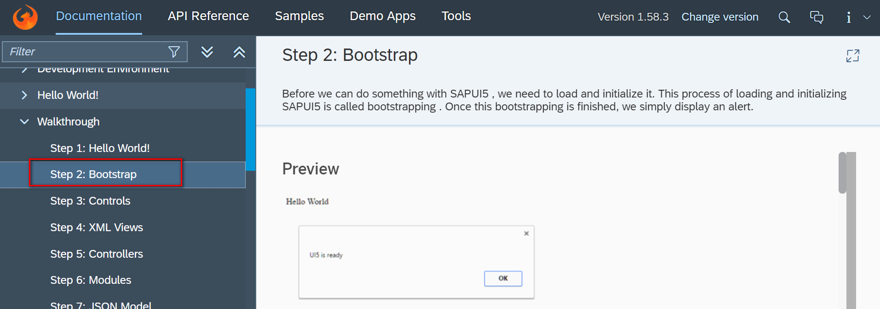

Followed after walkthrough 1 Hello World

Code

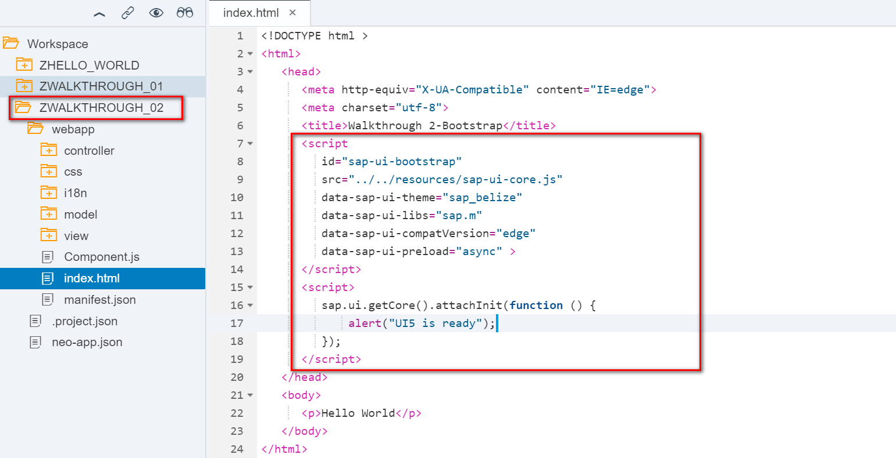

Result

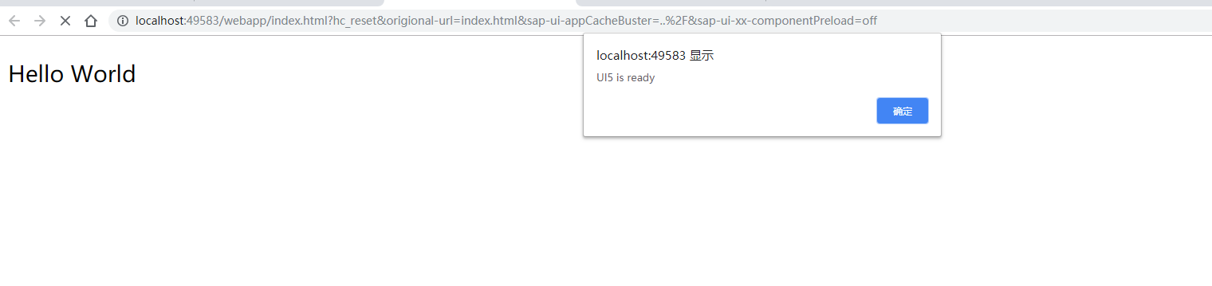

2018/11/01 Xiaomi Beijing Zac,Xie